

PROJECT REPORT



SUBMITTED BY

TEAM LEADER : ANUSHIYA.S

TEAM MEMBERS: ARRIM SHEMOLIN

ASHLIN JEBISHA

AATHIRA

ASHLIN JIBI

**Data Analytics Powered By Tableau**

**PROJECT TITTLE**

**Plugging into the Future: An Exploration of Electricity Consumption Patterns**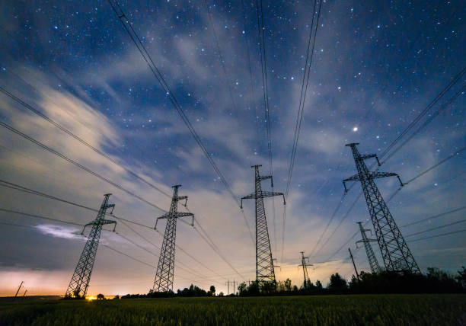

**INTRODUCTION**

Overview

Electricity is a form of energy involving the flow of electrons.

All matter is made up of atoms, which has a center called a nucleus.

The nucleus contains positively charged particles called protons and uncharged particles called neutrons.

Analysing Electricity Consumption in India from Jan 2019 till 5th December 2020.

This dataset contains a record of Electricity consumption in each states of India.

Here we aregoing to analyse State wise , Region wise and Overall Electricity consumption in India.

Purpose

By analyzing the electricity consumption, we can find the highest and lowest electricity usage

We can get the complete comparision

**Problem Definition and Design thinking**

Empathy map

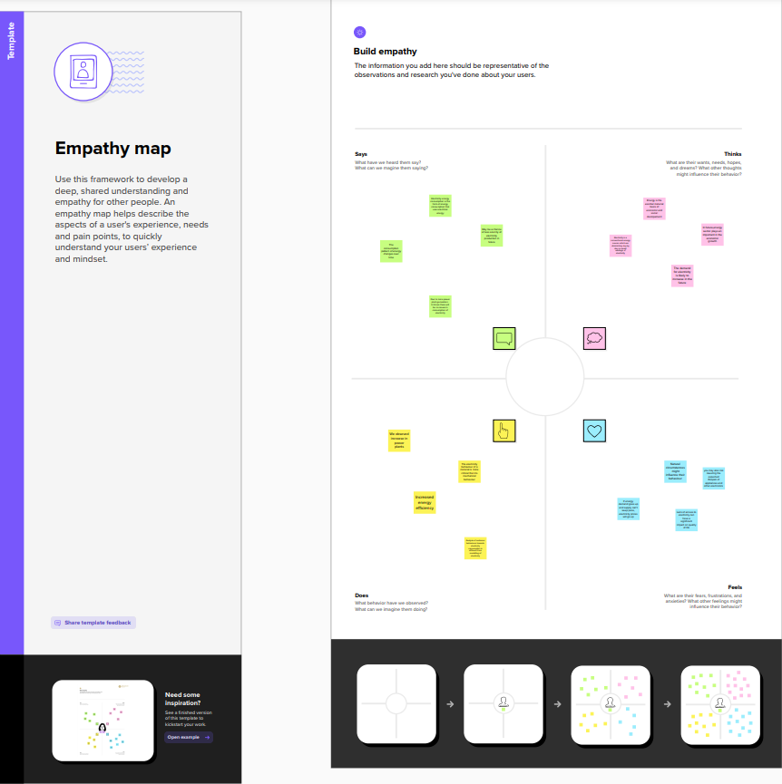

Ideation & Brainstorming Map

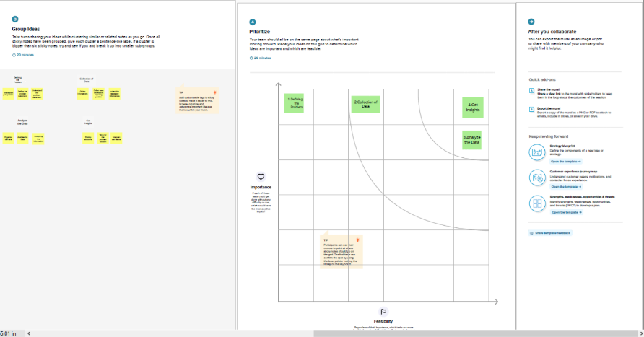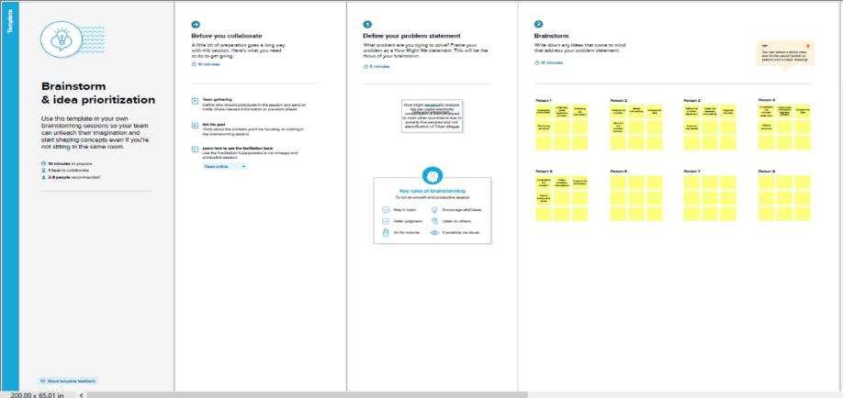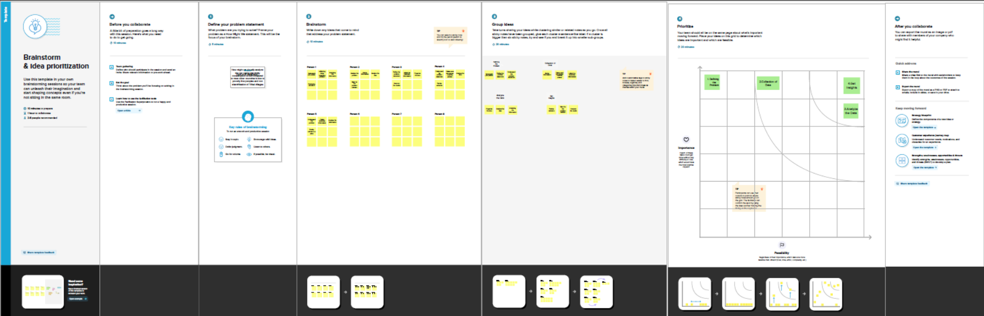

**RESULT**

**DASHBOARD**

**DASHBOARD1**

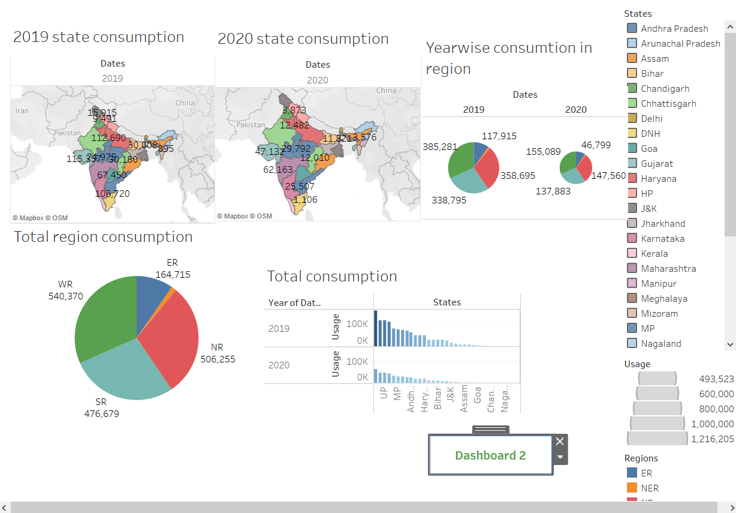

**DASHBOARD 2**

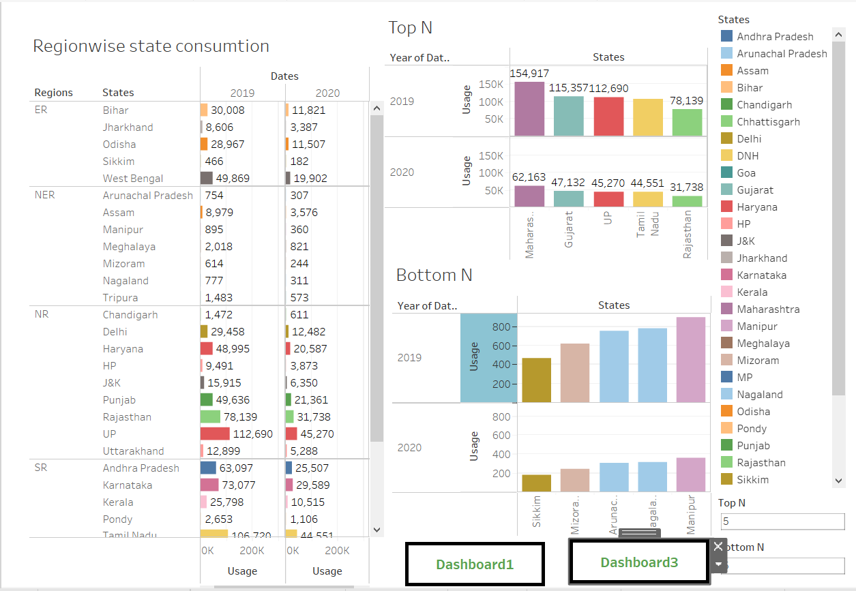

**DASHBOARD 3**

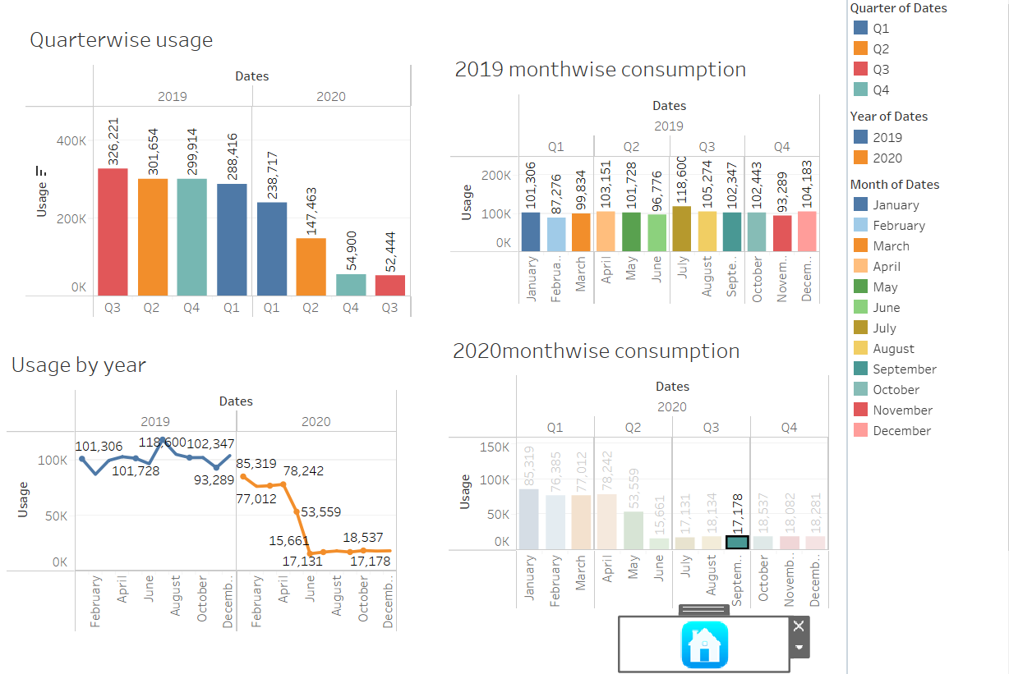

**STORY**

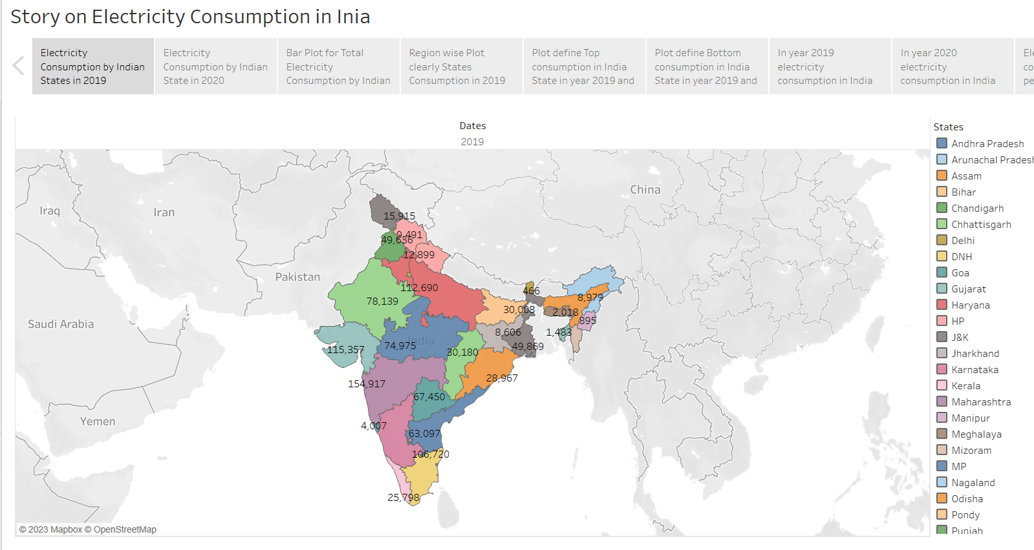

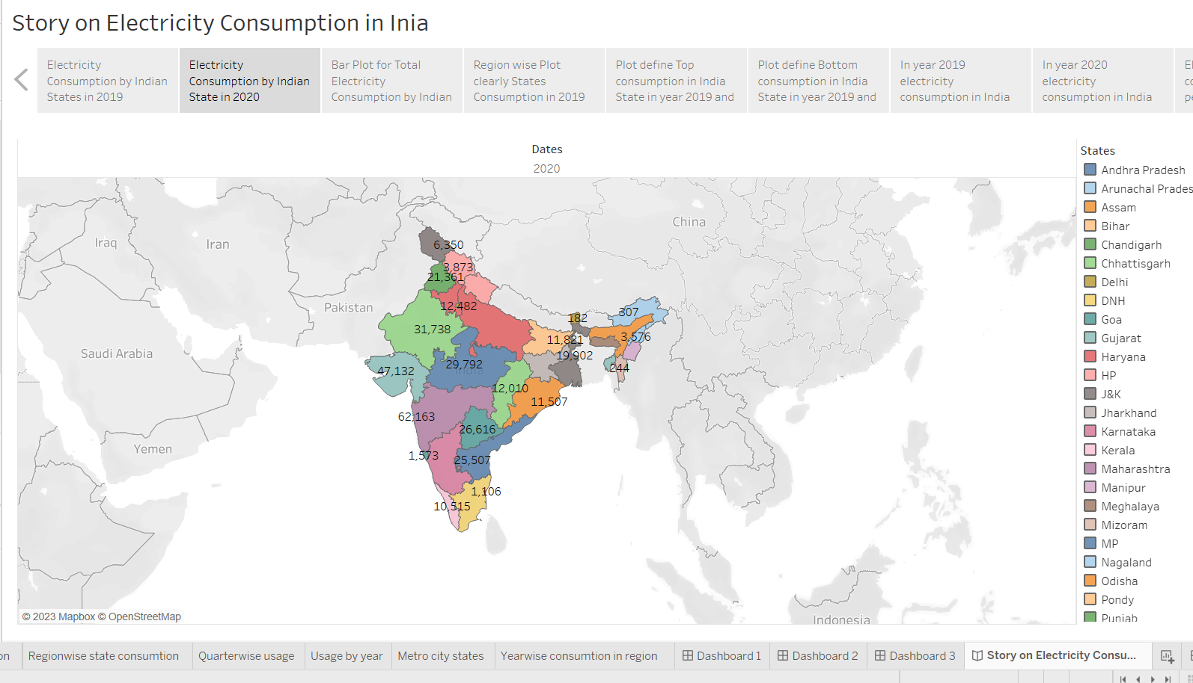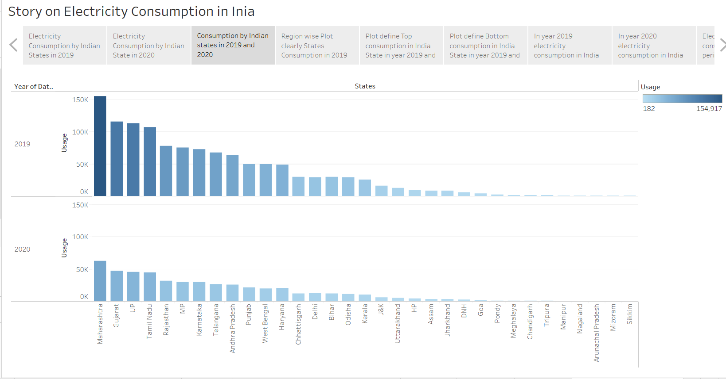

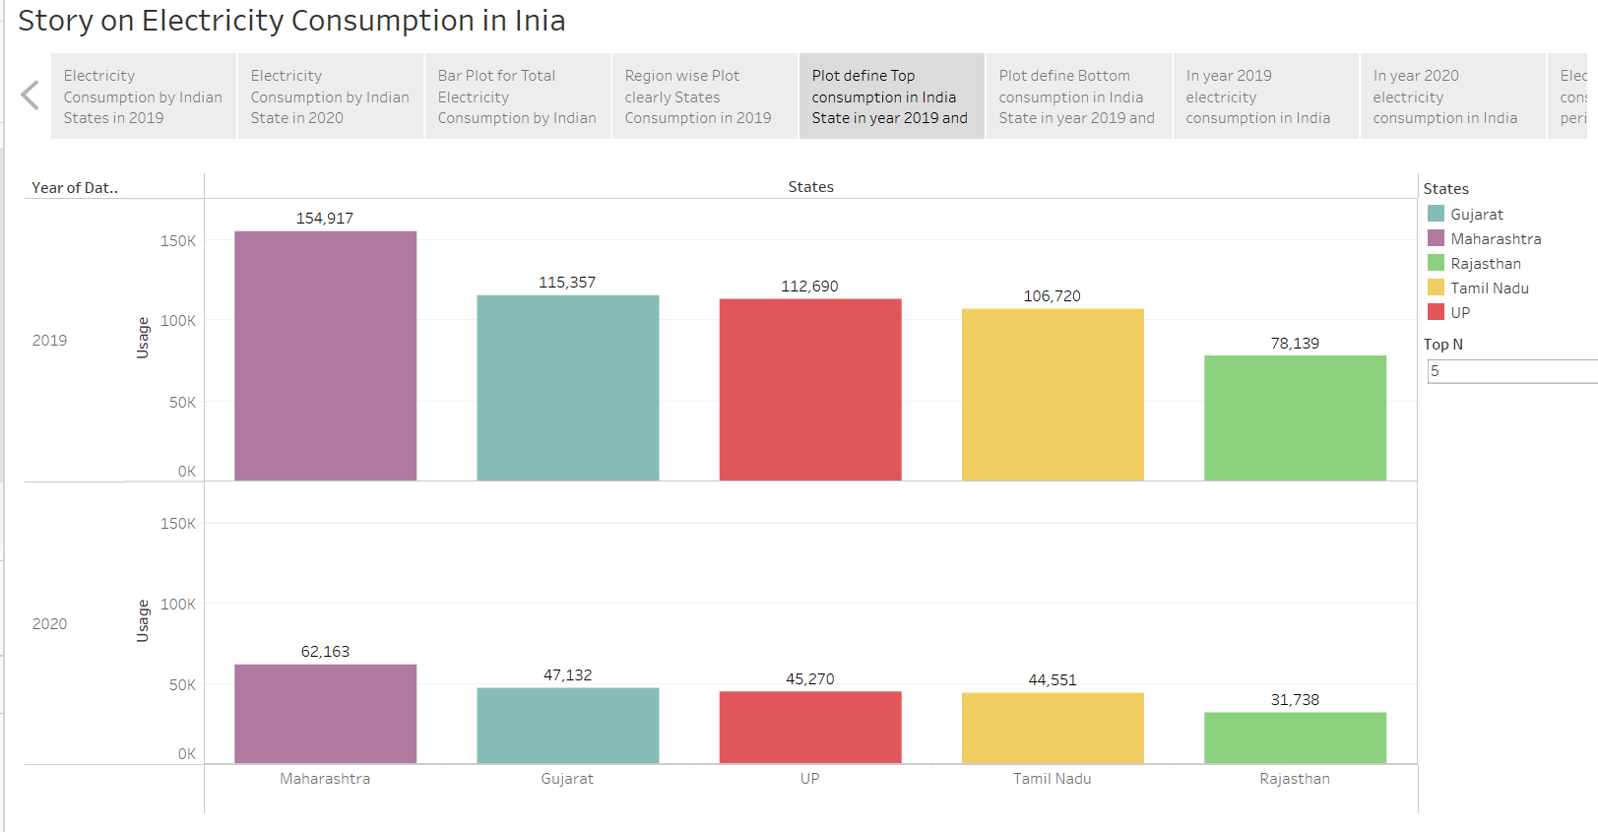

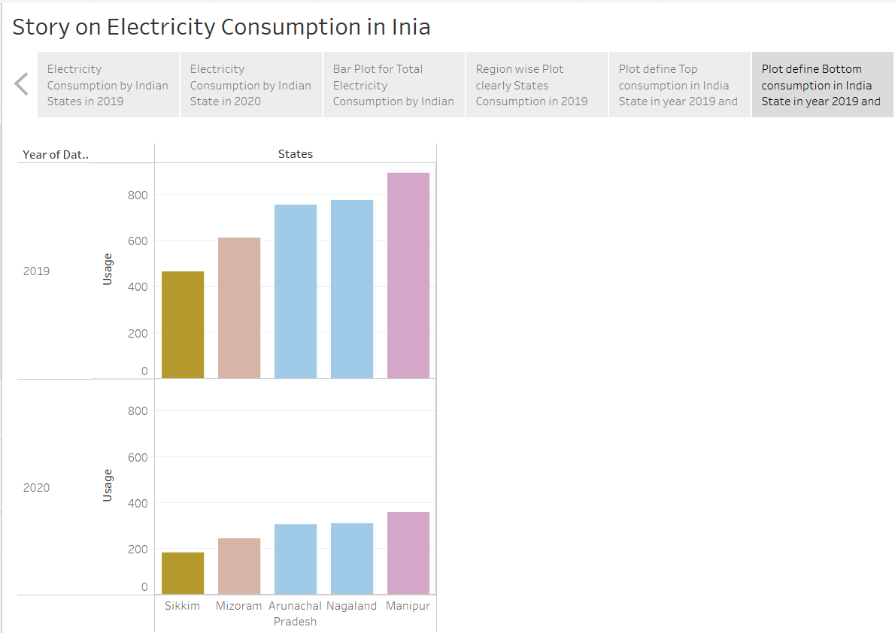

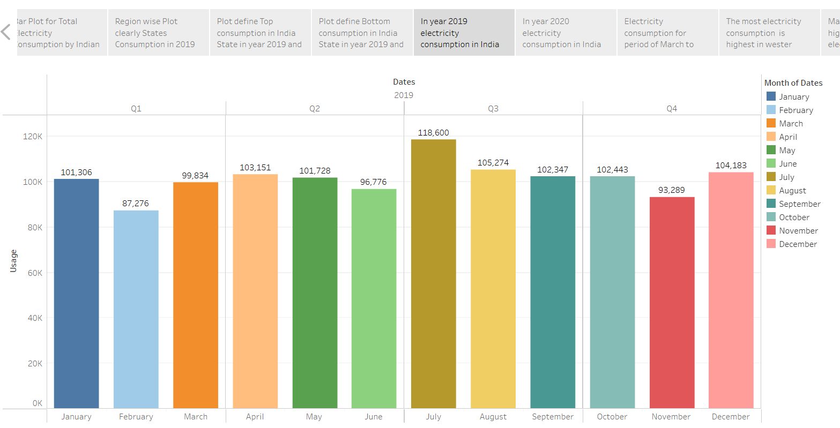

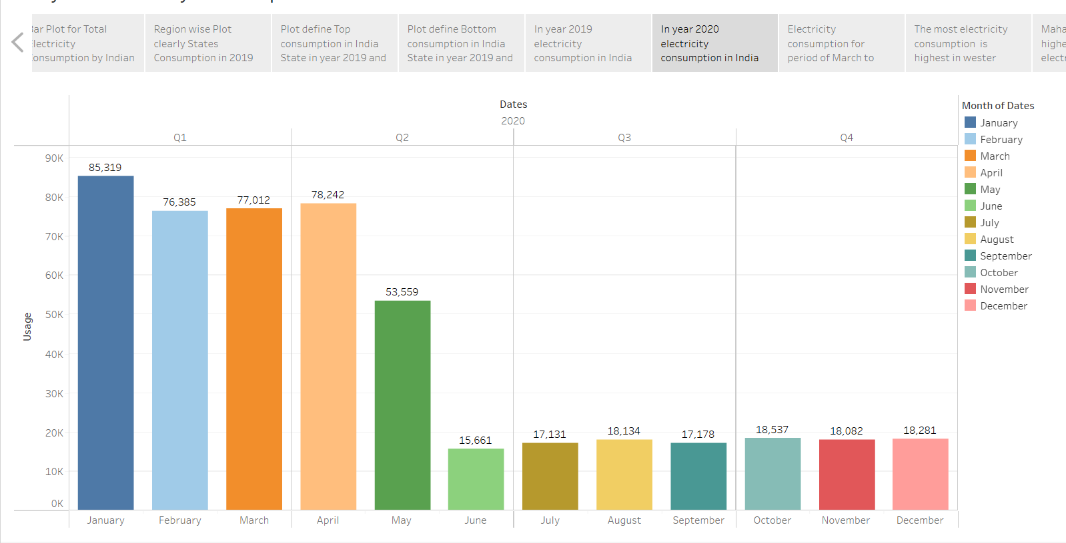

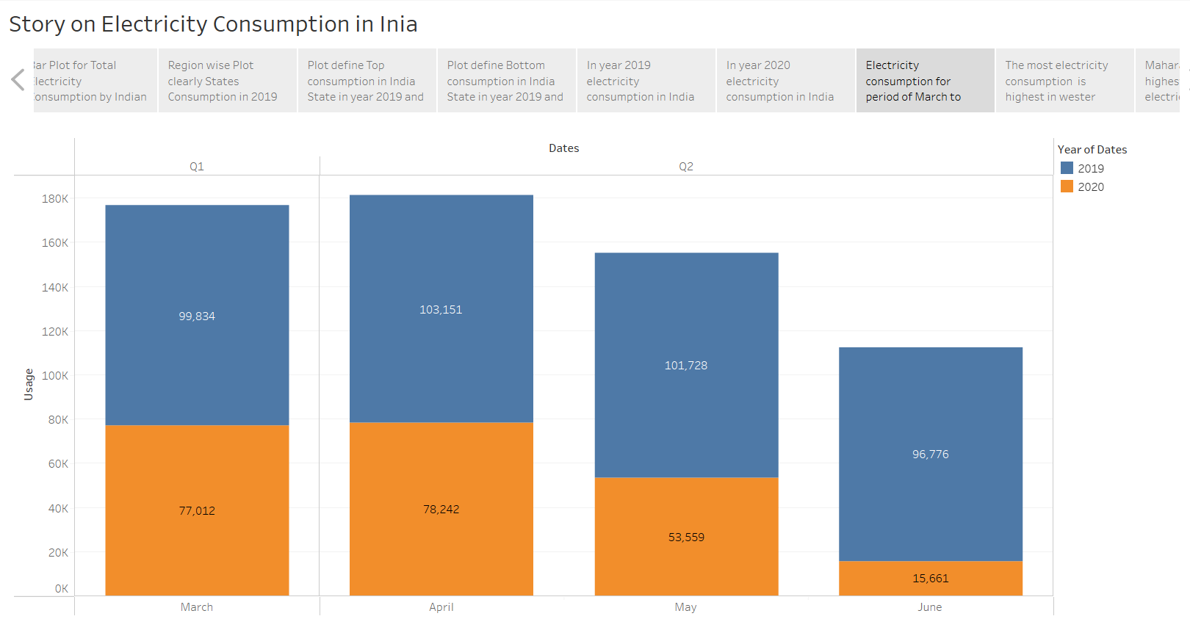

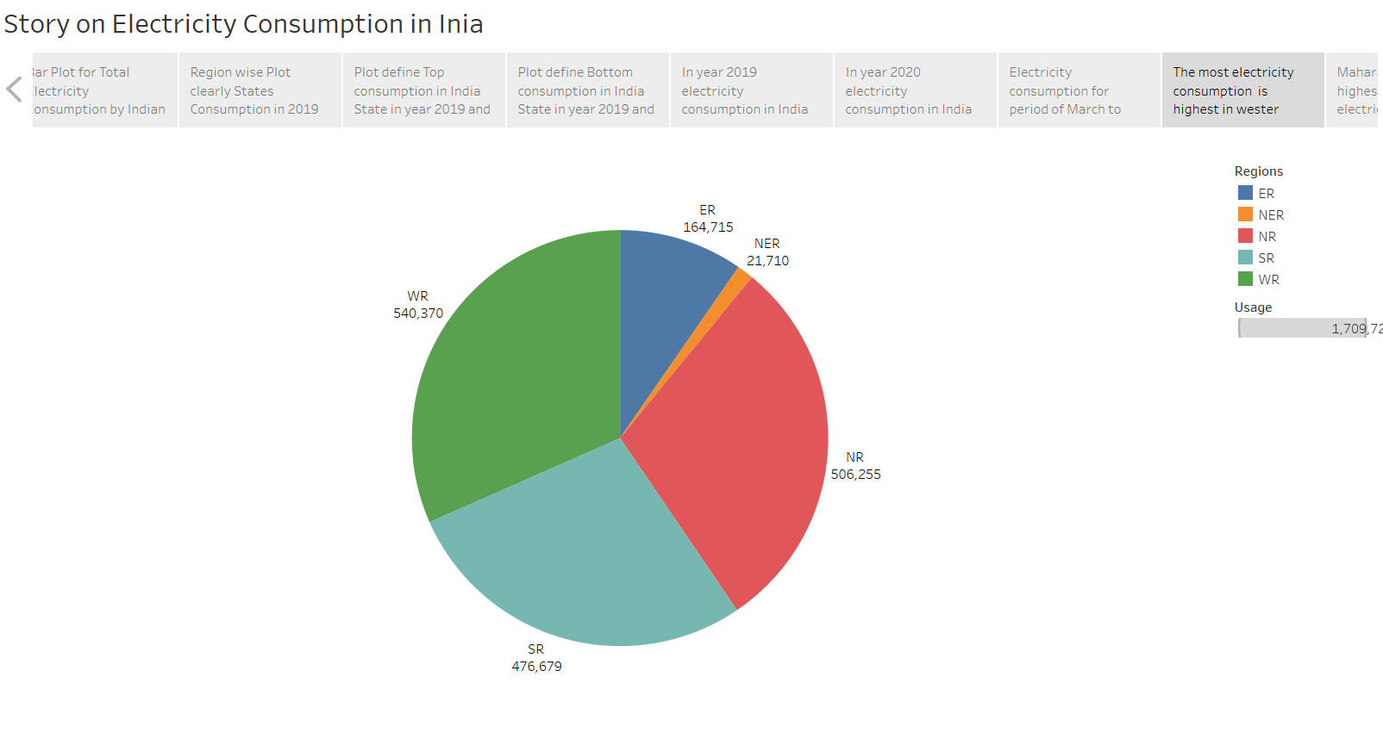

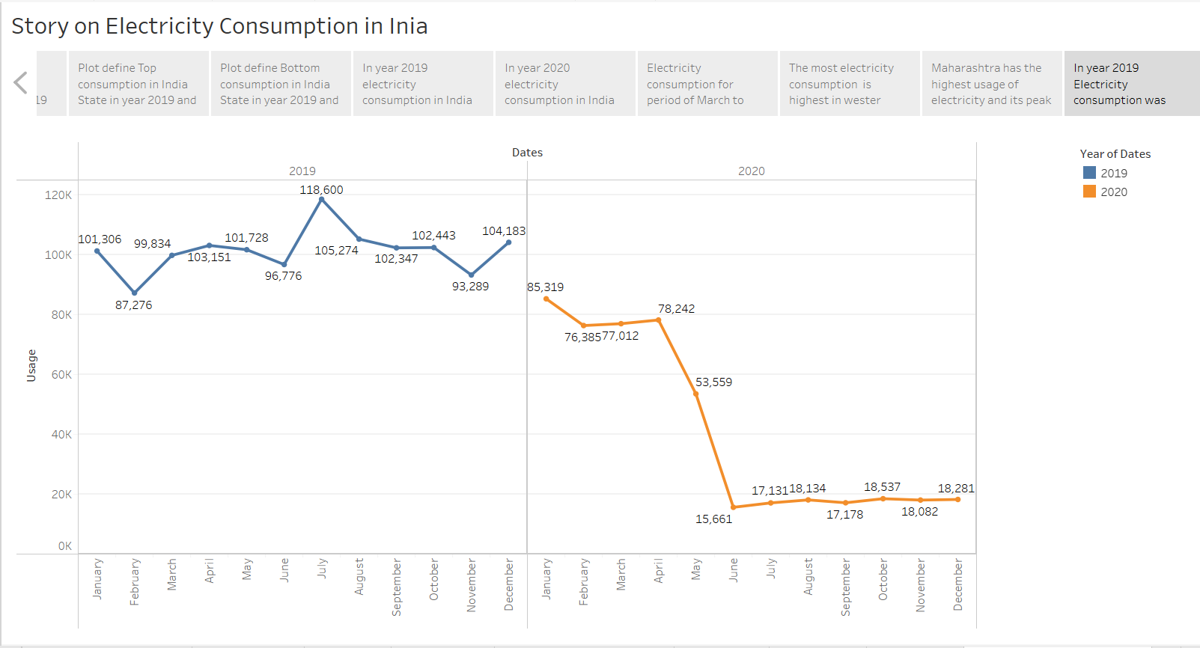

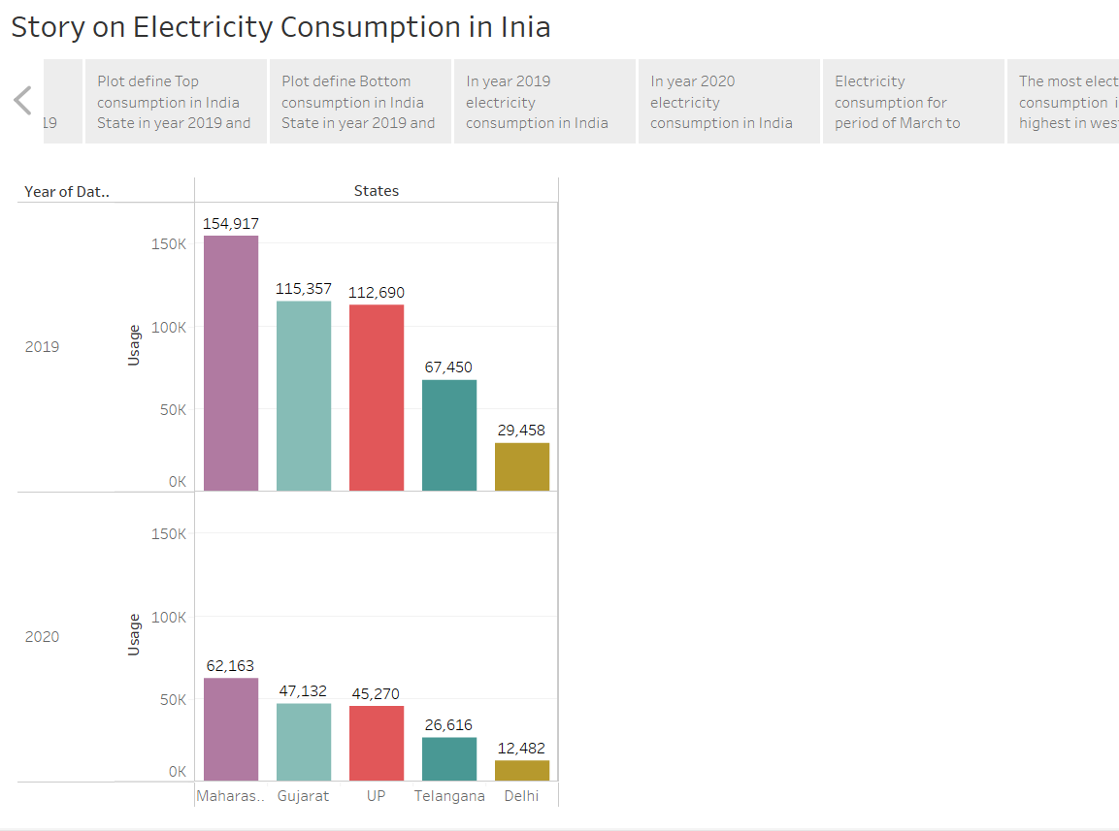

**WEB APPLICATION**

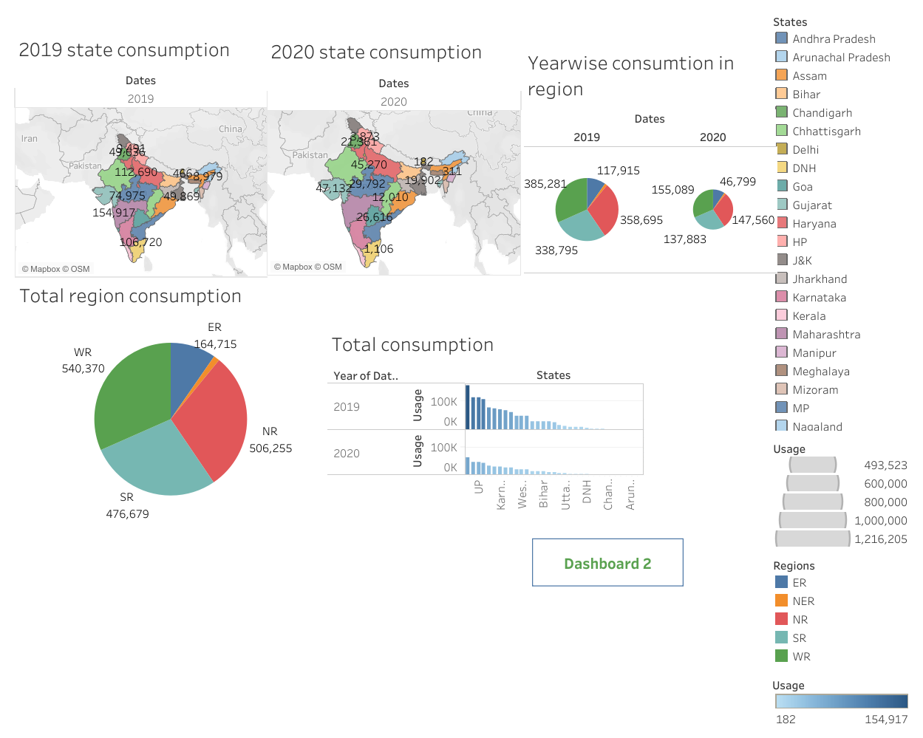

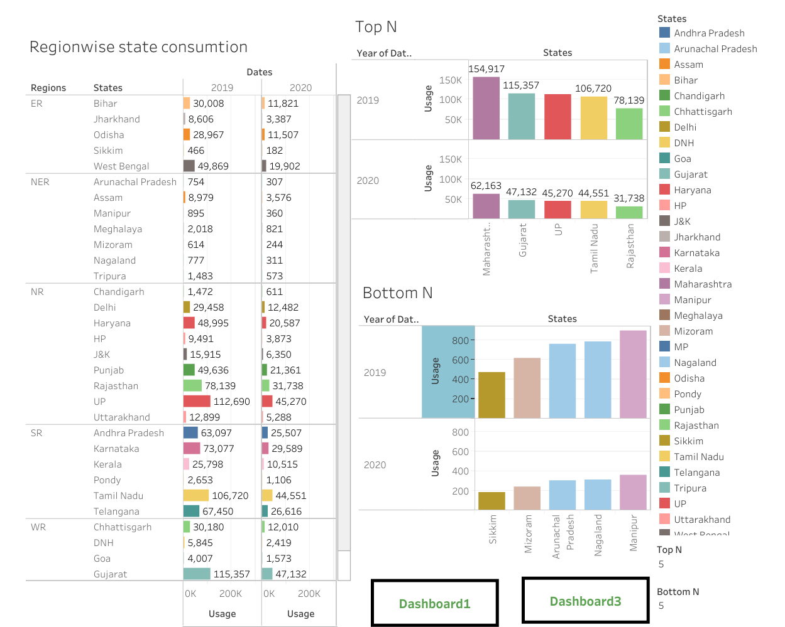

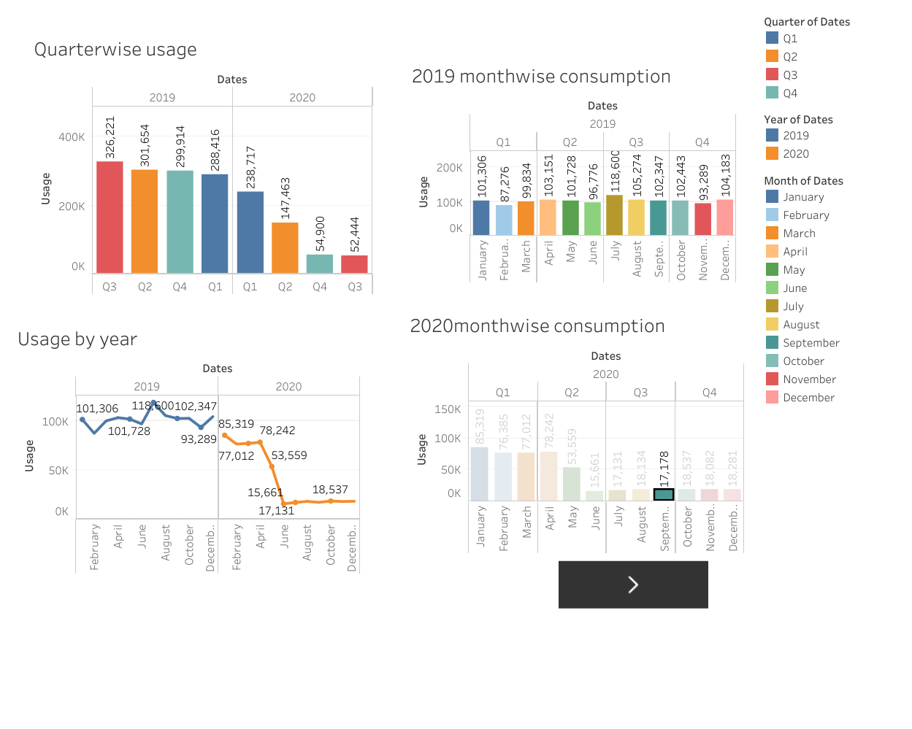

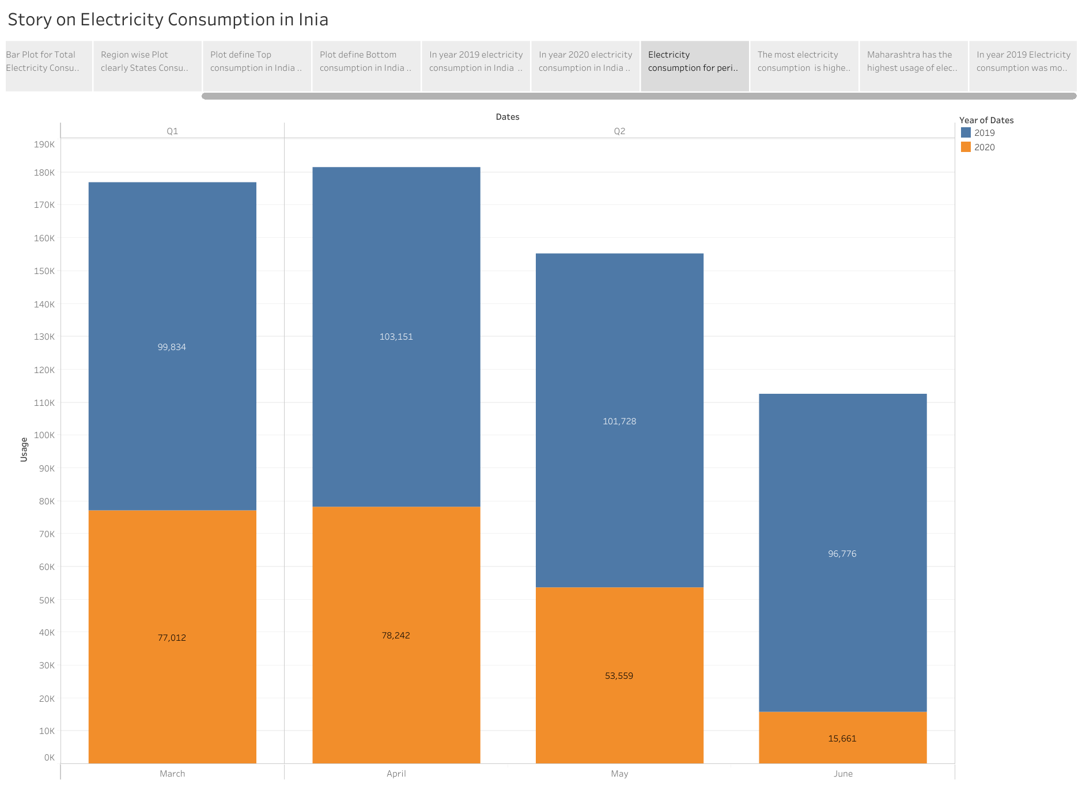

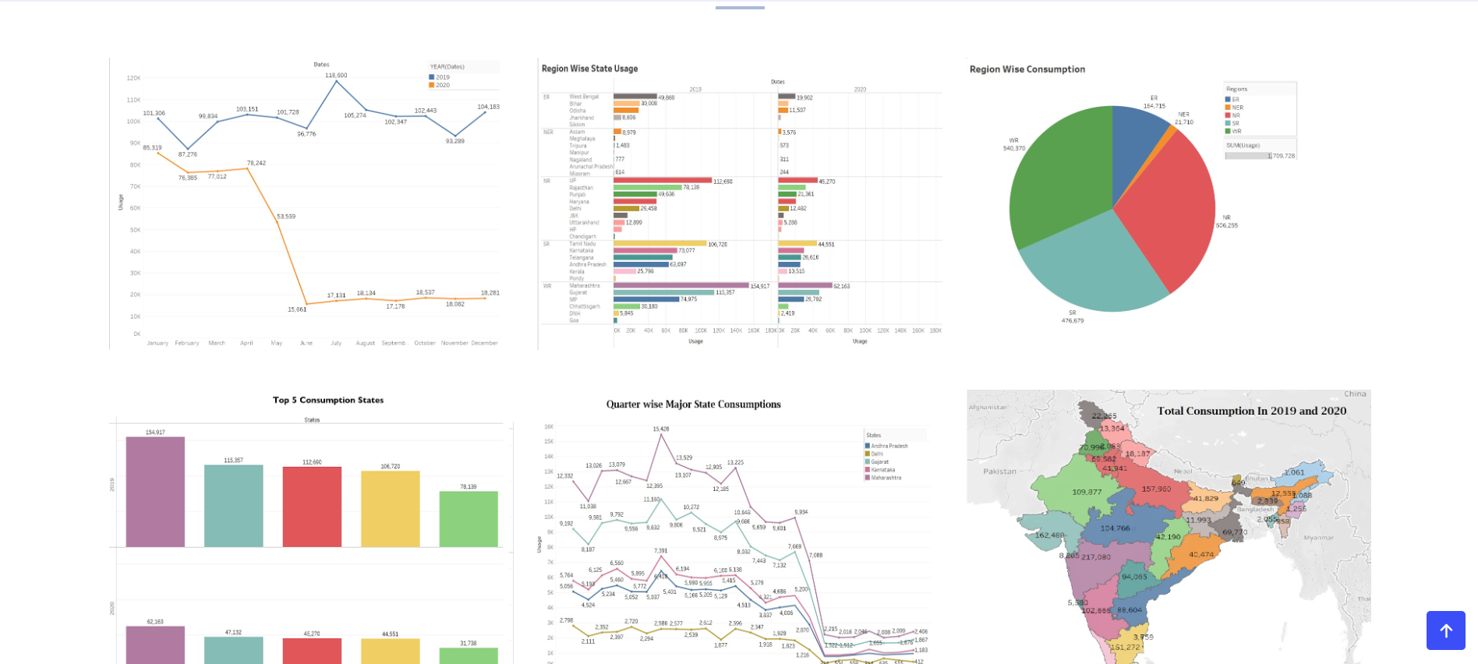**ADVANTAGES & DISADVANTAGES**

Advantages

This will gives the clear idea about the electricity usage from Jan 2019 till Dec 2020 in Indian States.

This will also gives the region wise electricity consumption

Disadvantages

The analysis of electricity consumption does not gives the clear information about the what source of electricity is used in different regions in India.

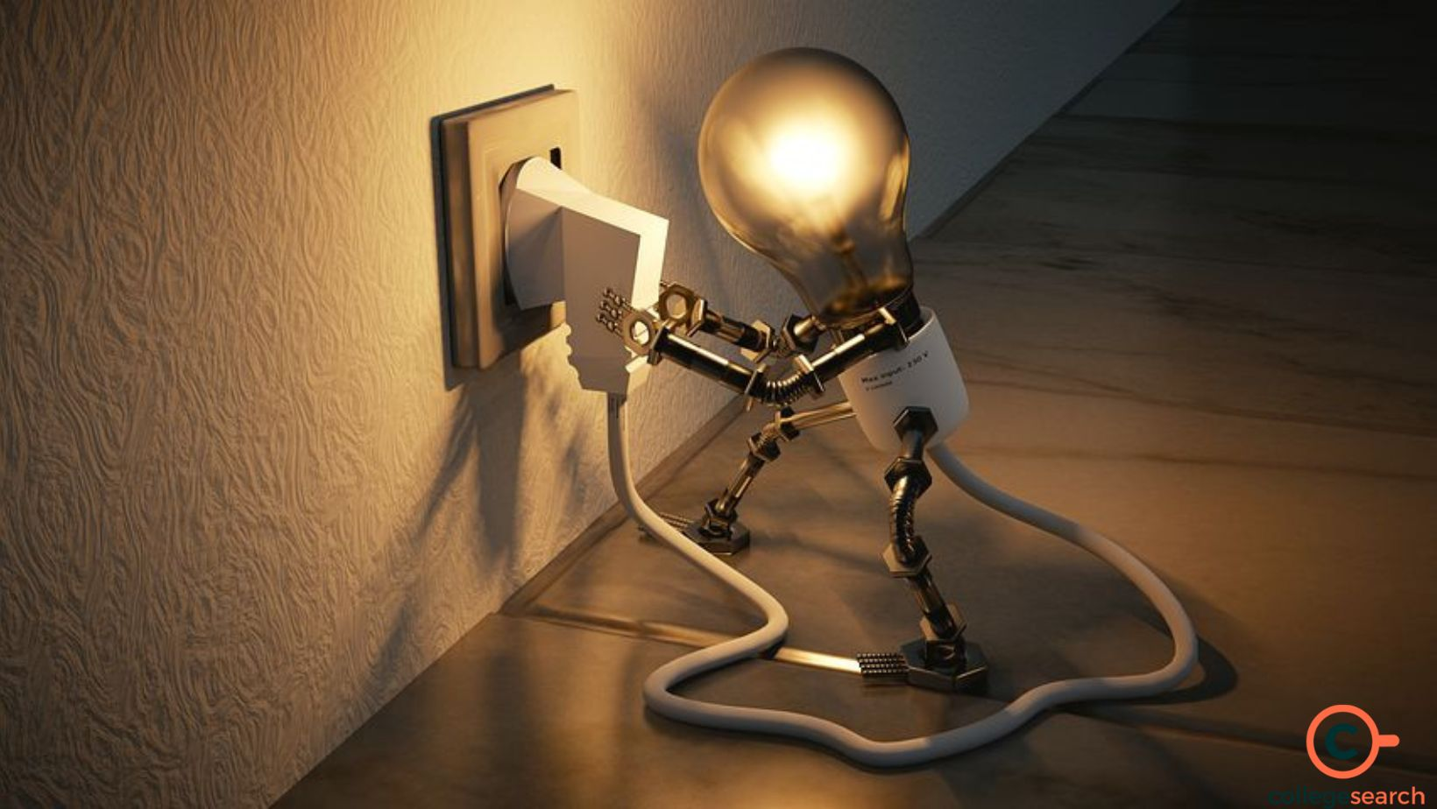

**APPLICATIONS**

* By using this analysis the experts can easily find the solution for electricity shortage.
* This might useful in the process of increasing the electricity consumption.

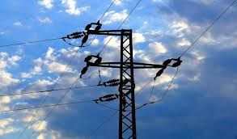

**CONCLUSION**

Electricity Consumption States.

Maharashtra is the Highest Electricity consumption user of India.

Gujarat is the Second Highest Electricity consumption user of India.

Sikkim is the Lowest Electricity Consumption user of India .

Electricity Consumption States.

Maharashtra is the Highest Electricity consumption user of India.

Gujarat is the Second Highest Electricity consumption user of India.

Sikkim is the Lowest Electricity Consumption user of India .

Electricity Consumption before and during Lockdown in India

Electricity consumption was more in 2019 in month of March-June before Lockdown

Electricity Consumption was less in 2020 in month of March-June during the Lockdown

Electricity Consumption in Quarters

Electricity Consumption in 2019 for Quarter 3 was Highest.

Electricity Consumption in 2019 for Quarter 1 was Lowest.

Electricity Consumption in 2020 for Quarter 3 was Lowest.

Electricity Consumption in 2020 for Quarter 1 was Highest.

Electricity Consumption in Regions

Total Electricity consumption in Western Region is Highest.

Total Electricity consumption in North Eastern Region is Lowest.

Electricity Consumption in 2020 for Quarter 3 was Lowest.

Electricity Consumption in 2020 for Quarter 1 was Highest.

FUTURE SCOPE

Electricity will largely replace petrol and diesel as a fuel for road vehicles. It will also replace the natural gas and oil we burn to heat our homes and run our industries. In short, electricity will grow in importance as a carbon-free energy carrier.

